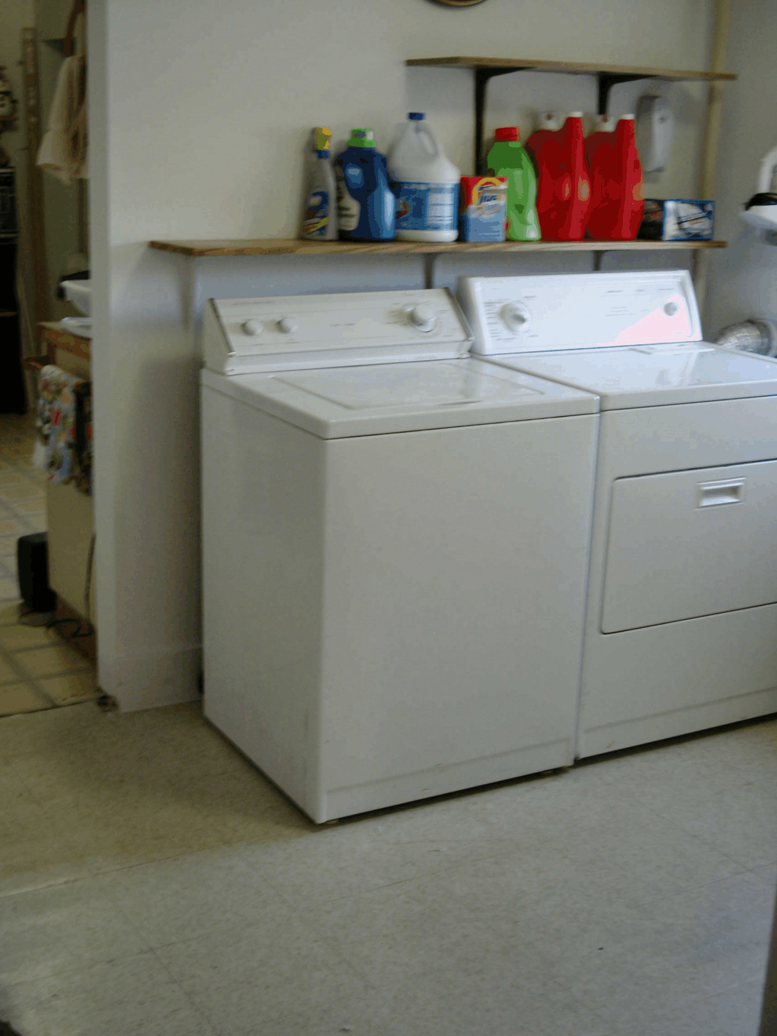

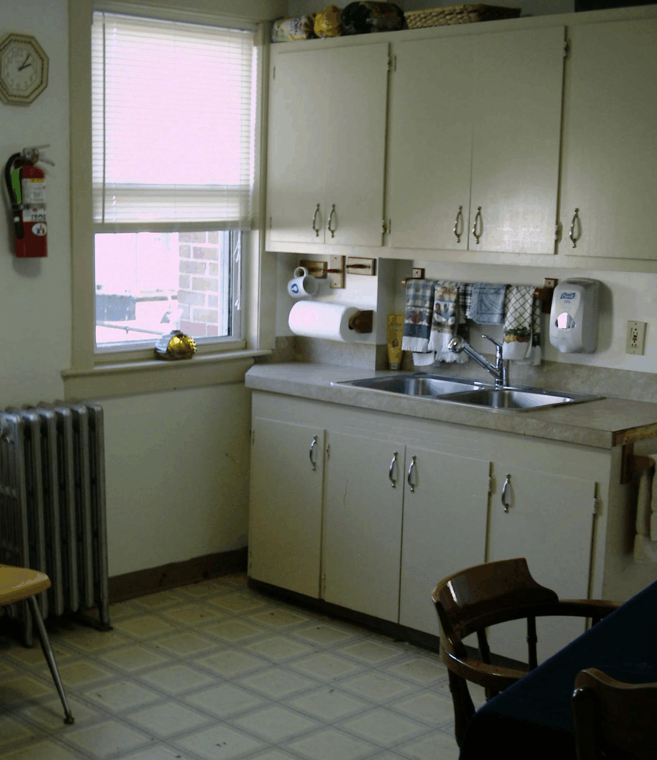
Located just two (2) blocks east of the Verizon Wireless Arena, close to many 12 step meetings, and close to Manchester’s central bus lines, you will find this location is a great place to call home.

THE GENDRON HOUSE
HOUSE BENEFITS:

- A SAFE, CLEAN, & SOBER ENVIRONMENT.
- All Utilities Included.
- House Fund Program.
- Cable in Each Room.
- On-Site Laundry Facilities.
- Newly Remodeled Bathrooms.
- Program Fees Ranging From $130.00 to $145.00 per Week.
- Off Street Private Parking.
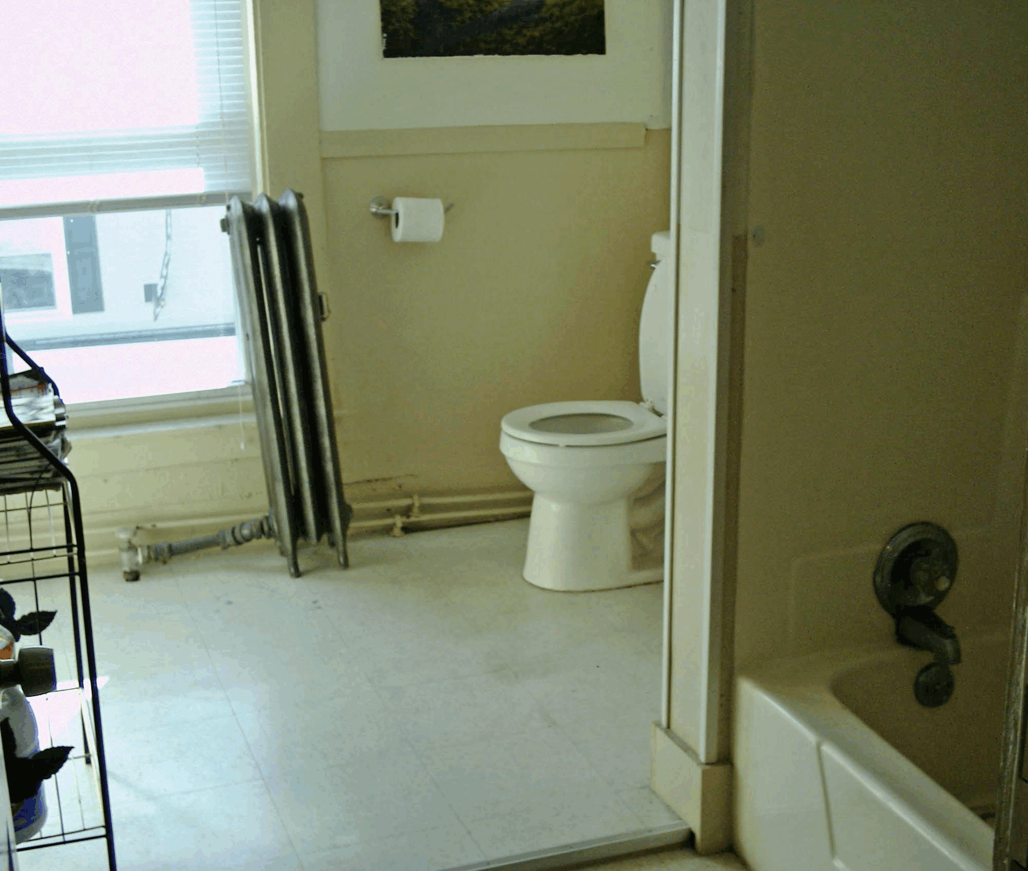

THE GENDRON HOUSE

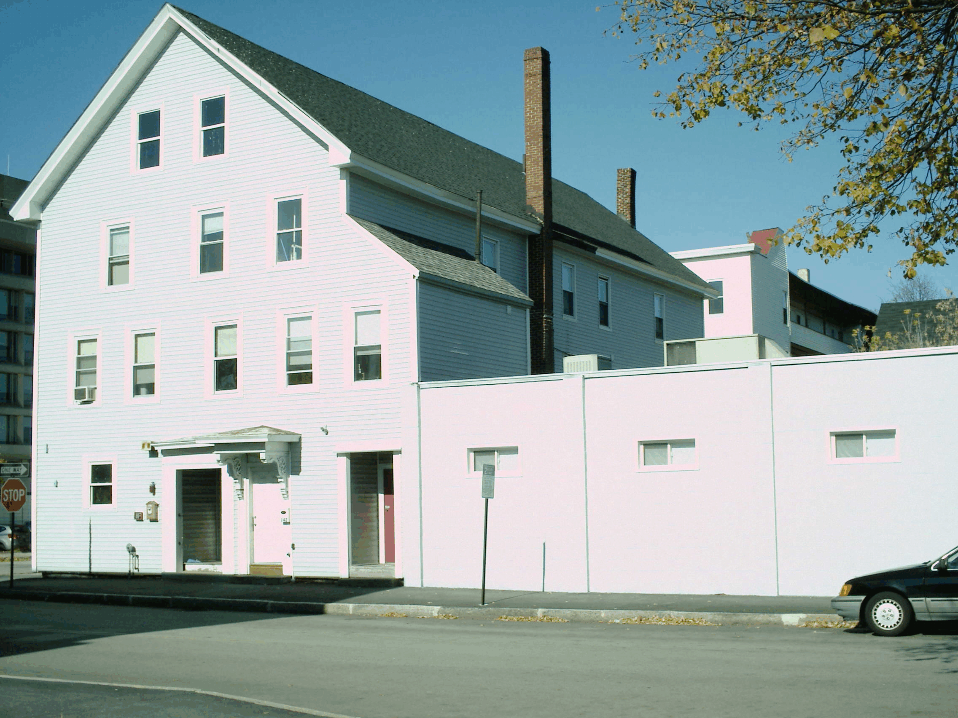

142 Central Street
Manchester, NH 03103
Phone: 1-603-623-8778
Fax: 1-603-626-5811

HELPING HANDS OUTREACH CENTER

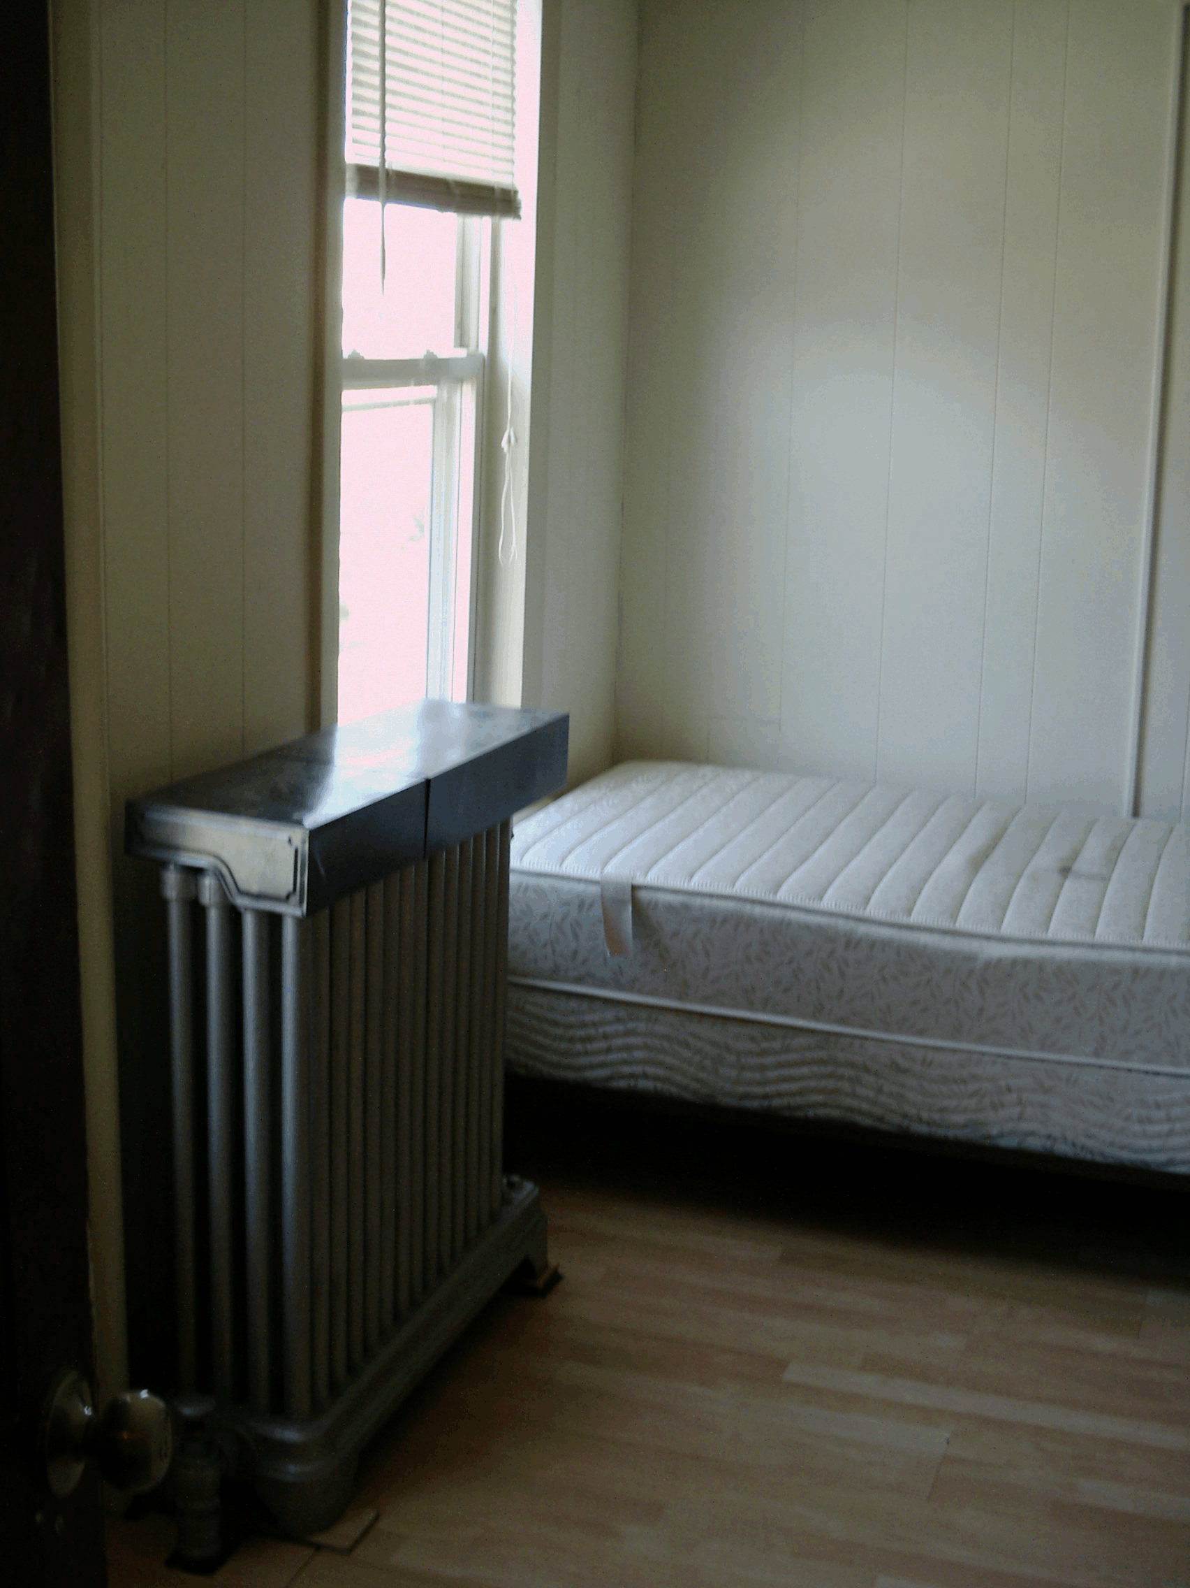
The Gendron House was purchased by Helping Hands Outreach Ministries (Helping Hands Outreach Center, 50 Lowell Street, Manchester, NH 03103) and was established as a men’s sober house in January of 2008. Located on the corner of Pine and Central Streets in Manchester, NH. This house offers men in recovery from drug and alcohol addiction a safe, clean, and sober environment. In the years that the house has been in operation, many improvements have been made to the property with newly remodeled bathrooms, kitchen, laundry room, and a new positive attitude. With fees ranging from $130.00 to $145.00 per week, all utilities included, and on site management available to respond to questions and concerns you may have while you are in 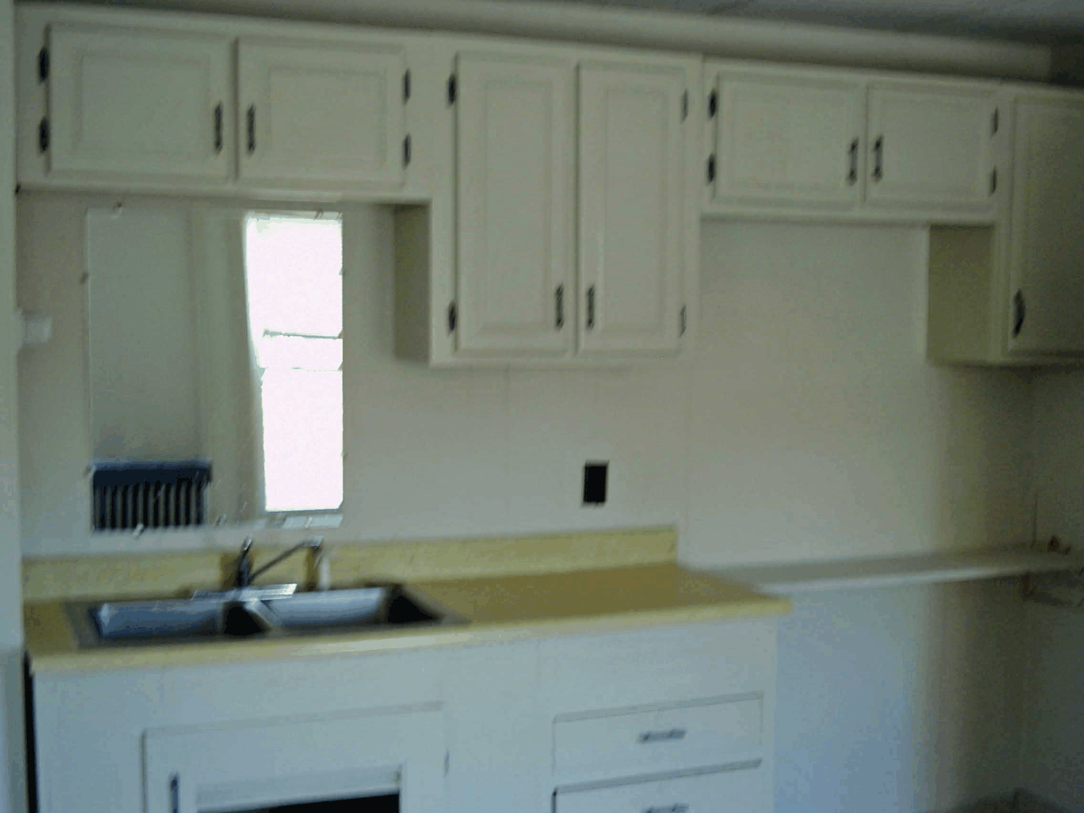program here, you will find The Gendron House a comfortable, safe, and affordable place to call home.

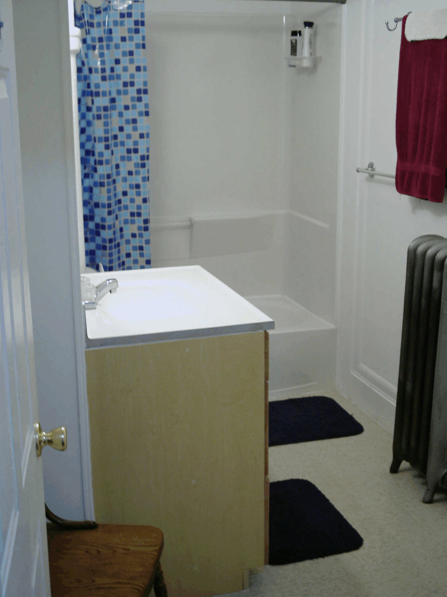

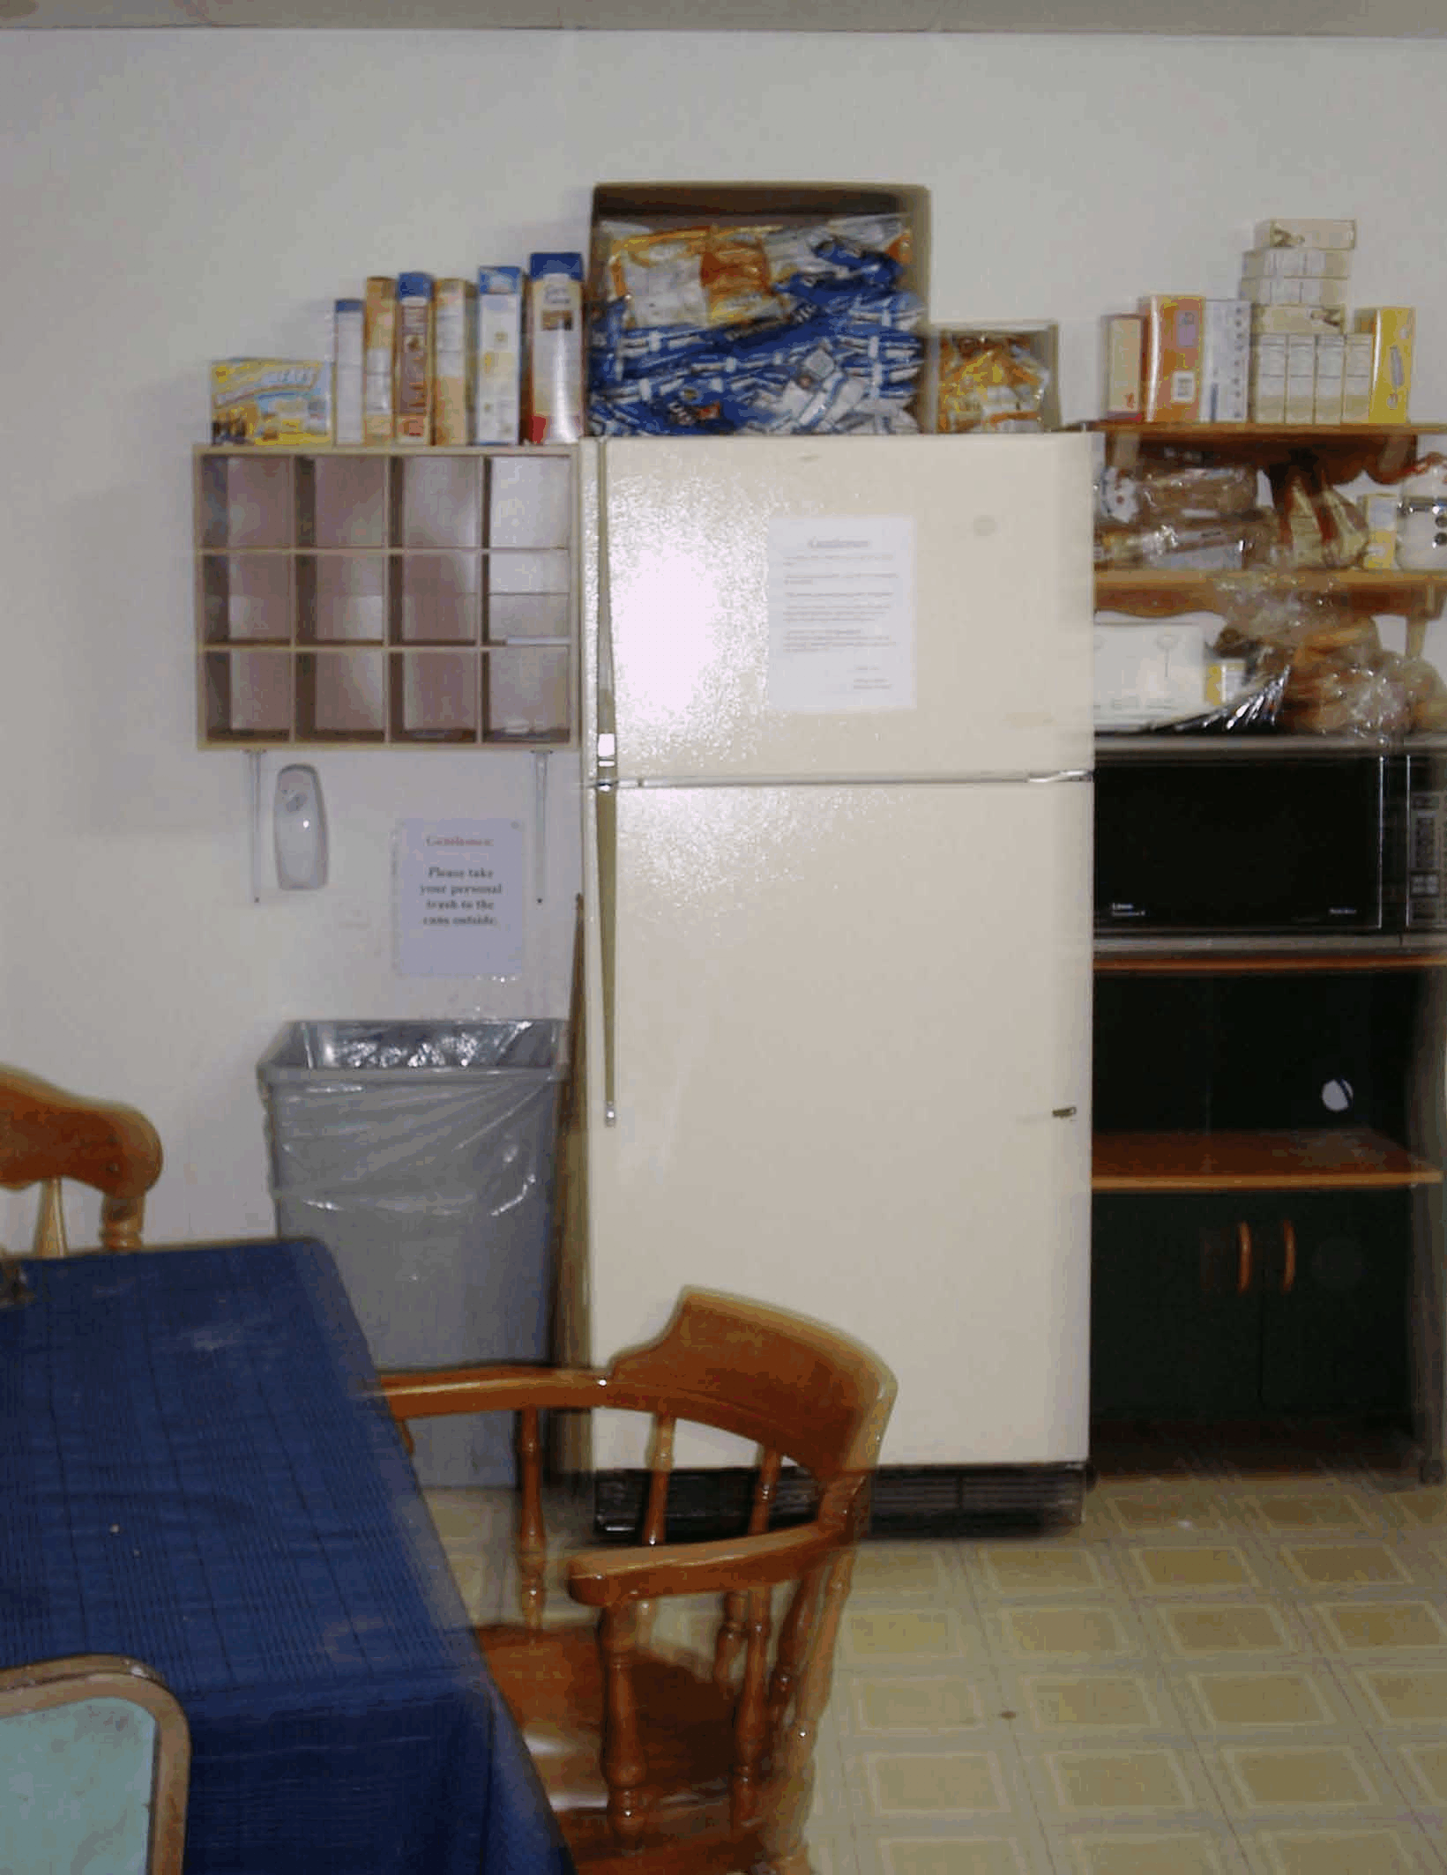
HOUSE FUND PROGRAM:

- DINNER SERVED M-F @6: PM.
- LAUNDRY DETERGENT.
- FABRIC SOFTENER.
- FRUITS & VEGETABLES.
- SNACKS.
- CHIPS, CANDY, & GUM.
- TOILET PAPER.
- BEVERAGES.
- BREADS & CEREALS.
- ITEMS BROUGHT TO HOUSE.

